Project Design Phase-II
Data Flow Diagram & User Stories

Date | 30 September 2026
Team ID | SWTID-2026-7693
Project Name | AI - FAQ ASSISTANT
Maximum Marks | 4 Marks
Data Flow Diagrams:
A Data Flow Diagram (DFD) is a visual representation of how data moves through the AI FAQ Assistant system. It shows how users submit questions, how the system processes the questions using AI/NLP, how relevant information is retrieved from the FAQ knowledge base, and how answers are generated and displayed to the user. It also represents data storage, administrator activities, and the handling of unanswered questions.
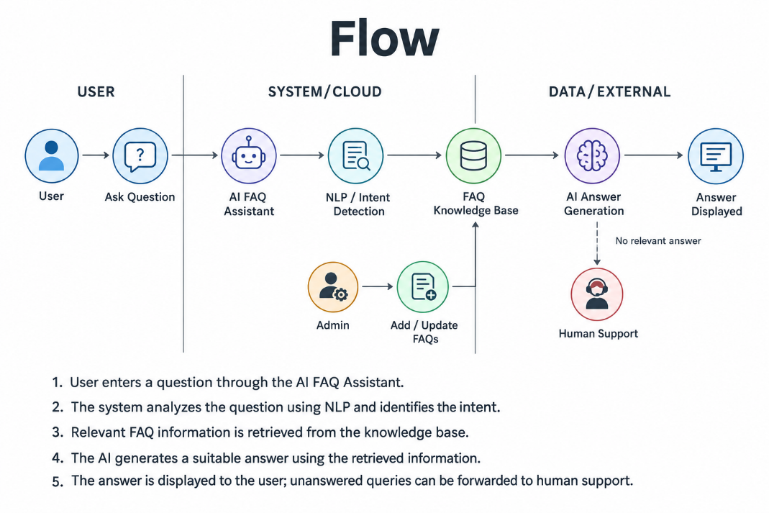
Example: (Simplified)
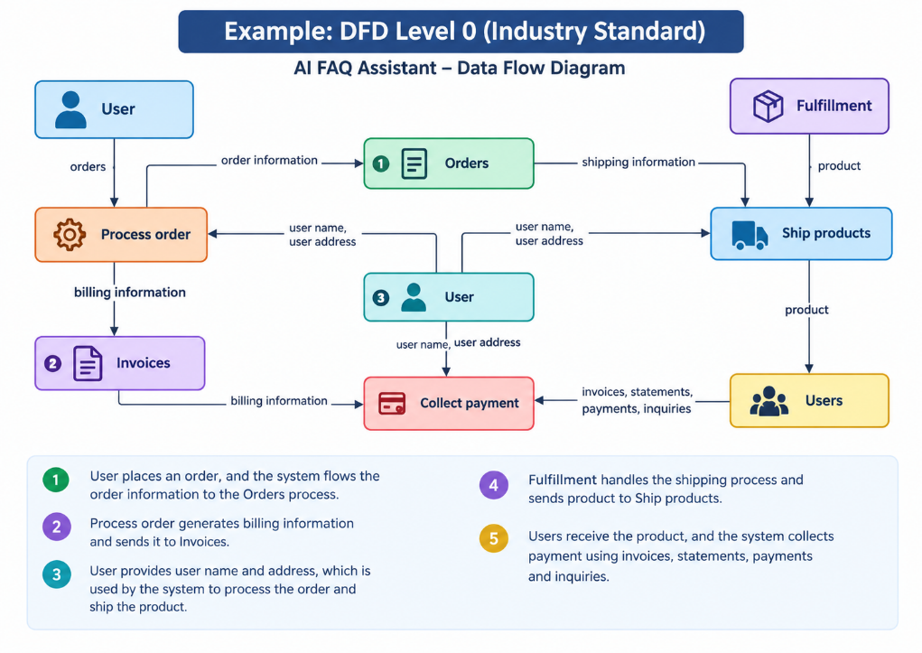
User Stories
Use the below template to list all the user stories for the product.
User Type | Functional Requirement (Epic) | User Story Number | User Story / Task | Acceptance criteria | Priority | Release
Customer (Mobile user) | Registration | USN-1 | As a user, I can register for the application by entering my email, password, and confirming my password. | I can access my account / dashboard | High | Sprint-1
Customer (Mobile user) | Registration | USN-2 | As a user, I will receive confirmation email once I have registered for the application | I can receive confirmation email & click confirm | High | Sprint-1
Customer (Mobile user) | Registration | USN-3 | As a user, I can register for the application through Facebook | I can register & access the dashboard with Facebook Login | Low | Sprint-2
Customer (Mobile user) | Registration | USN-4 | As a user, I can register for the application through Gmail | I can register and access the dashboard using Google Login. | Medium | Sprint-1
Customer (Mobile user) | Login | USN-5 | As a user, I can log into the application by entering email & password | I can successfully log in with valid credentials and access the dashboard. | High | Sprint-1
Customer (Mobile user) | Dashboard |  | As a user, I can view the AI FAQ Assistant dashboard after logging in. | Dashboard displays FAQ search, AI assistant, categories, and recent queries. | High | Sprint-1
  USN-6
Customer (Web user) | FAQ Search | USN-7 | As a web user, I can search for frequently asked questions using keywords | The system displays relevant FAQ answers based on my search keywords. | High | Sprint-1
Customer (Web user) | AI Assistant | USN-8 | As a web user, I can ask questions to the AI FAQ Assistant using natural language. | The AI assistant provides a relevant answer to the question. | High | Sprint-1
Customer (Web user) | Feedback | USN-9 | As a user, I can provide feedback on the answer received from the AI FAQ Assistant. | I can submit positive or negative feedback successfully. | Medium | Sprint-2
Customer Care Executive | Query Management | USN-10 | As a customer care executive, I can view questions that the AI assistant could not answer. | Unanswered or unresolved customer queries are displayed in the executive dashboard. | High | Sprint-2
Administrator | FAQ Management | USN-11 | As an administrator, I can add, edit, and delete FAQ questions and answers. | The administrator can successfully manage FAQ content and changes are reflected in the system. | High | Sprint-2

